Name: **ZOHAIB HASSAN SOOMRO**

RollNo#: **19SW42**

Subject: **Operating System**



**What is virtualization?**

Virtualization is the creation of a virtual -- rather than actual -- version of something, such as an operating system (OS), a server, a storage device or network resources.

Virtualization uses software that simulates hardware functionality to create a virtual system. This practice allows IT organizations to operate multiple operating systems, more than one virtual system and various applications on a single server. The benefits of virtualization include greater efficiencies and economies of scale.

OS virtualization is the use of software to allow a piece of hardware to run multiple operating system images at the same time. The technology got its start on mainframes decades ago, allowing administrators to avoid wasting expensive processing power.

**How virtualization works**

Virtualization describes a technology in which an application, guest OS or data storage is abstracted away from the true underlying hardware or software.

A key use of virtualization technology is server virtualization, which uses a software layer -- called a hypervisor -- to emulate the underlying hardware. This often includes the CPU's memory, input/output (I/O) and network traffic.

Hypervisors take the physical resources and separate them so they can be utilized by the virtual environment. They can sit on top of an OS or they can be directly installed onto the hardware. The latter is how most enterprises virtualize their systems.

The Xen hypervisor is an open source software program that is responsible for managing the low-level interactions that occur between virtual machines (VMs) and the physical hardware. In other words, the Xen hypervisor allows for the simultaneous creation, execution and management of various virtual machines in one physical environment.

**Deadlock:**

**Deadlock** is very serious condition which may result into total collapse of the system. It is a situation where a set of processes is blocked because each process is holding a resource and waiting for another resource acquired by another process.

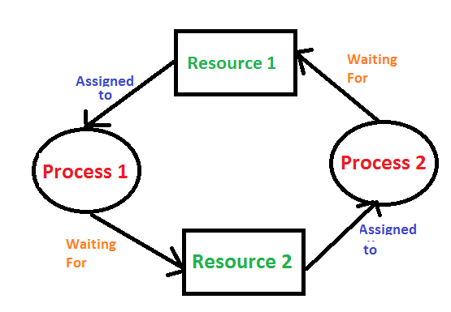

e.g Two trains are coming toward each other on the same track and there is only one track, none of the trains can move once they are in front of each other. A similar situation occurs in operating systems when there are two or more processes that hold some resources and wait for resources held by other(s).

**what causes deadlock to occur?**

Process(es) needing resources that another process has. This blocks from sharing resources such as memory, devices, links. Under normal operation, a resource allocation proceeds like this:

1. Request a resource (suspend until available if necessary).

2. Use the resource.

3. Release the resource.

**What are four conditions for deadlock to occur:**

**1. Mutual Exclusion-**

By this condition,

There must exist at least one resource in the system which can be used by only one process at a time.

If there exists no such resource, then deadlock will never occur.

Printer is an example of a resource that can be used by only one process at a time.

**2. Hold and Wait-**

By this condition,

There must exist a process which holds some resource and waits for another resource held by some other process.

**3. No Preemption-**

By this condition,

Once the resource has been allocated to the process, it can not be preempted.

It means resource can not be snatched forcefully from one process and given to the other process.

The process must release the resource voluntarily by itself.

**4. Circular Wait-**

By this condition,

All the processes must wait for the resource in a cyclic manner where the last process waits for the resource held by the first process.

**How to deal with deadlock?**

**1. Deadlock Prevention :**

The strategy of deadlock prevention is to design the system in such a way that the possibility of deadlock is excluded. Indirect method prevent the occurrence of one of three necessary condition of deadlock i.e., mutual exclusion, no pre-emption and hold and wait. Direct method prevent the occurrence of circular wait.

**Prevention techniques –**

**Mutual exclusion – is supported by the OS.**

**Hold and Wait –** condition can be prevented by requiring that a process requests all its required resources at one time and blocking the process until all of its requests can be granted at a same time simultaneously. But this prevention does not yield good result because :

• long waiting time required

• in efficient use of allocated resource

• A process may not know all the required resources in advance

**No pre-emption –** techniques for ‘no pre-emption are’

If a process that is holding some resource, requests another resource that can not be immediately allocated to it, the all resource currently being held are released and if necessary, request them again together with the additional resource.

If a process requests a resource that is currently held by another process, the OS may pre-empt the second process and require it to release its resources. This works only if both the processes do not have same priority.

**Circular wait** One way to ensure that this condition never hold is to impose a total ordering of all resource types and to require that each process requests resource in an increasing order of enumeration, i.e., if a process has been allocated resources of type R, then it may subsequently request only those resources of types following R in ordering.

**2. Deadlock avoidance:**

This approach allows the three necessary conditions of deadlock but makes judicious choices to assure that deadlock point is never reached. It allows more concurrency than avoidance detection

A decision is made dynamically whether the current resource allocation request will, if granted, potentially lead to deadlock. It requires the knowledge of future process requests. Two techniques to avoid deadlock :

Process initiation denial

Resource allocation denial

**Advantages of deadlock avoidance techniques:**

Not necessary to pre-empt and rollback processes

Less restrictive than deadlock prevention

**Disadvantages :**

Future resource requirements must be known in advance

Processes can be blocked for long periods

Exists fixed number of resources for allocation

**3. deadlock detection :**

Deadlock detection is used by employing and algorithm that tracks the circular waiting and killing one or more processes so that deadlock is removed. The system state is examined periodically to determine if a set of processes is deadlocked. A deadlock is resolved by aborting and restarting a process, relinquishing all the resources that the process held.

This technique does not limit resources access or restrict process action.

Requested resources are granted to processes whenever possible.

It never delays the process initiation and facilitates online handling.

The disadvantage is the inherent pre-emption losses.

**Techniques of encryption**

Conversion of plain text to cipher text(non-readable text) is called encryption. The purpose of encryption is to hide the data from being displayed to unauthorized parties. Encryption happens through keys and it is bidirectional which means whatever is encrypted can be decrypted back.

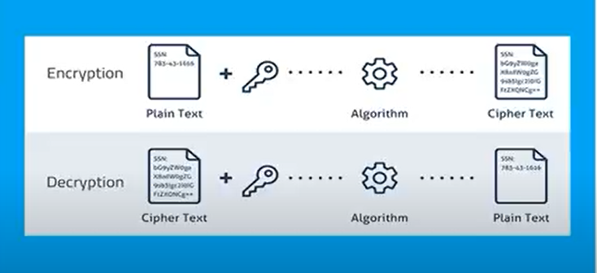

There are two types of encryption:

1. Symmetric encryption:

It is also called as **Secret key** encryption because it is a kind of encryption technique in which same key is used for encryption as well as decryption and this key is therefore called as secret key.

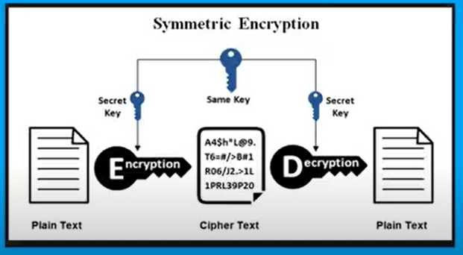

1. Asymmetric encryption:

It is a kind of encryption technique in which we have two type of keys the first one is called public key and the other is called private key. The public key is one that is used for encryption that’s why this mechanism is known as **Public key encryption** where as private key is used for decryption of encrypted data

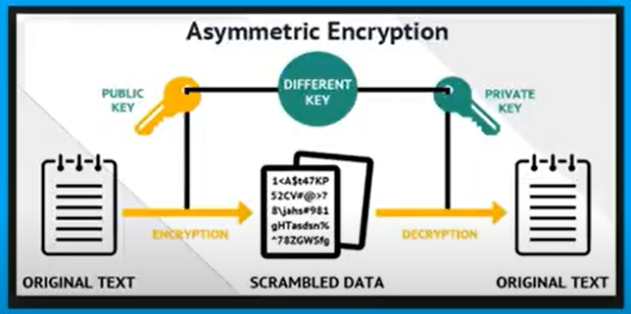

**Virtualization:**

Virtualization is a technique of how to separate a service from the underlying physical delivery of that service. It is the process of creating a virtual version of something like computer hardware. It was initially developed during the mainframe era. It involves using specialized software to create a virtual or software-created version of a computing resource rather than the actual version of the same resource. With the help of Virtualization, multiple operating systems and applications can run on same machine and its same hardware at the same time, increasing the utilization and flexibility of hardware.

In other words, one of the main cost effective, hardware reducing, and energy saving techniques used by cloud providers is virtualization. Virtualization allows to share a single physical instance of a resource or an application among multiple customers and organizations at one time. It does this by assigning a logical name to a physical storage and providing a pointer to that physical resource on demand. The term virtualization is often synonymous with hardware virtualization, which plays a fundamental role in efficiently delivering Infrastructure-as-a-Service (IaaS) solutions for cloud computing. Moreover, virtualization technologies provide a virtual environment for not only executing applications but also for storage, memory, and networking.